7.1.7 Green Practices
- Students, staff using
- Bicycles
- Public Transport
- Pedestrian Friendly Roads
- Plastic free campus
- Paperless office
- Green landscaping with trees and plants

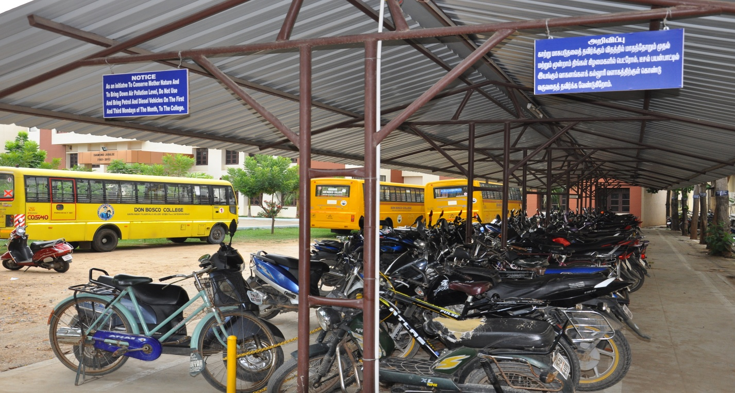
Bicycles Parking near Gate No 1

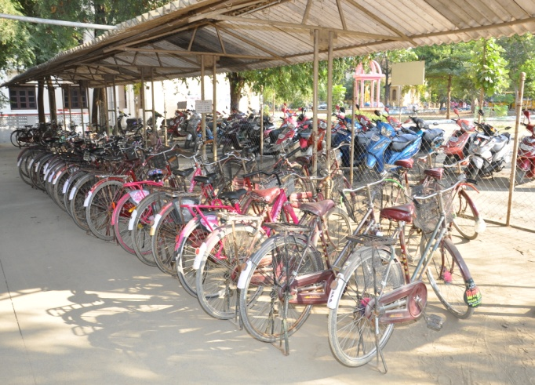
Bicycles Parking near Gate No 2

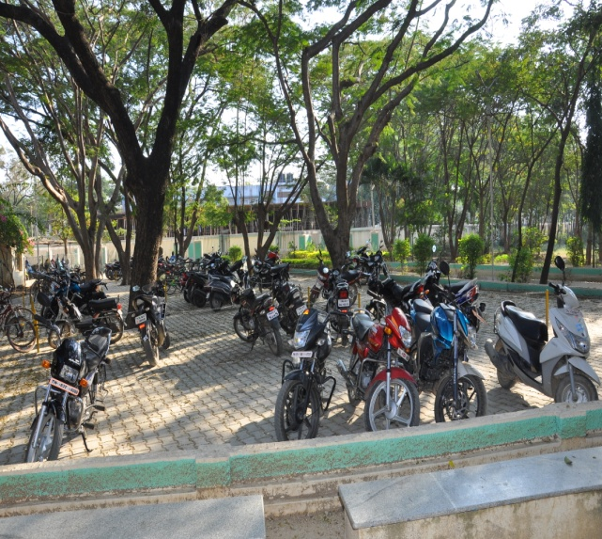
Two Wheeler Parking (MSW Block)

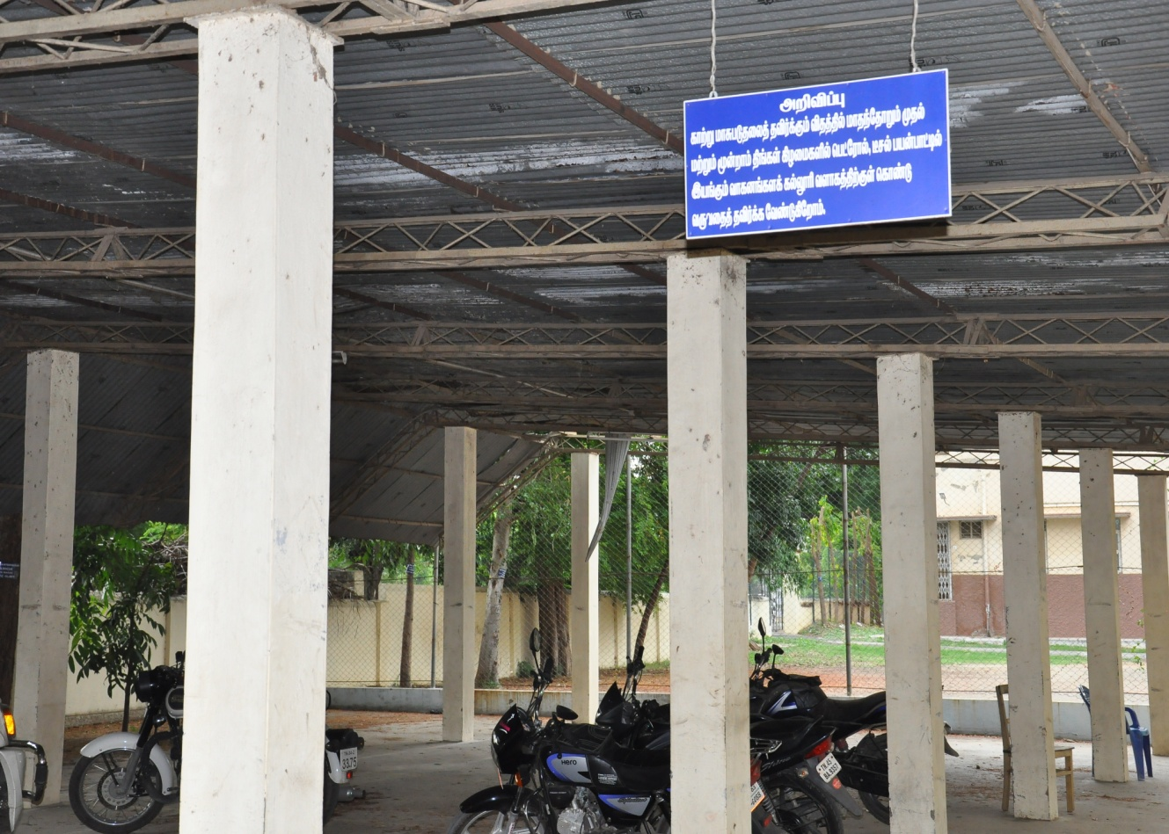
Two Wheeler Parking at Gate 3

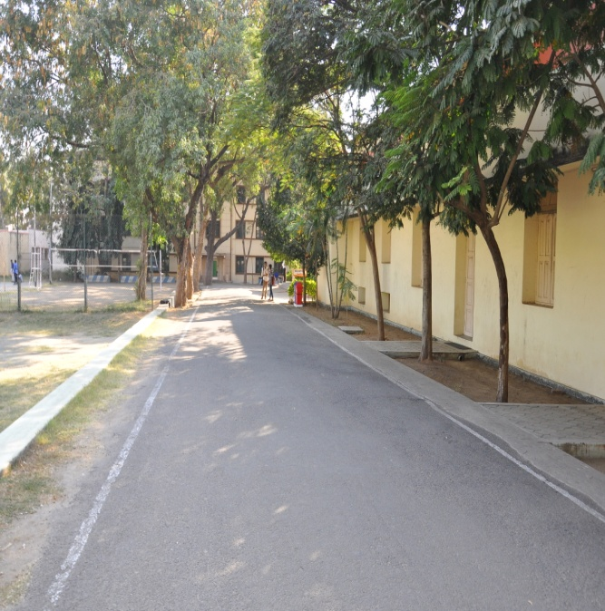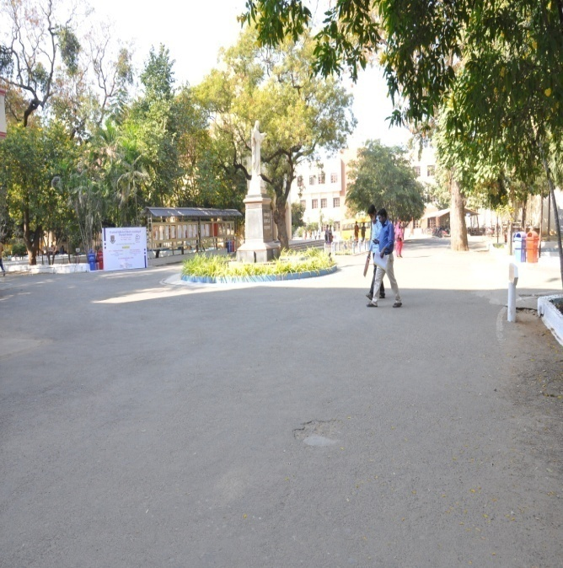
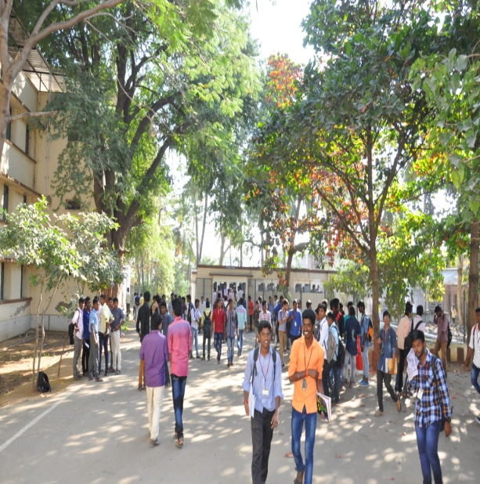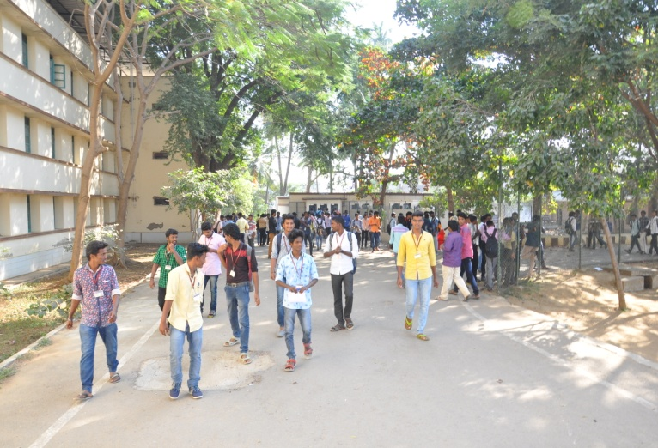
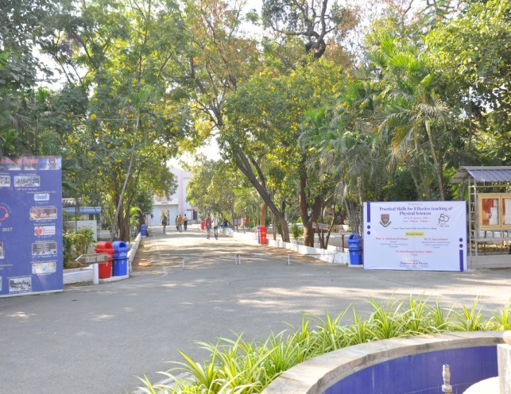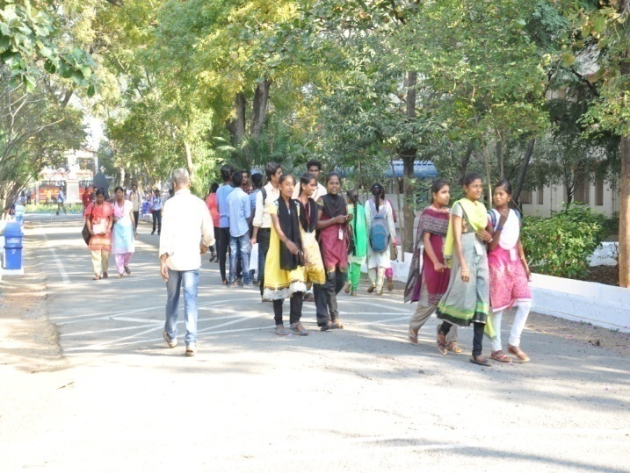
Pedestrian Friendly Roads
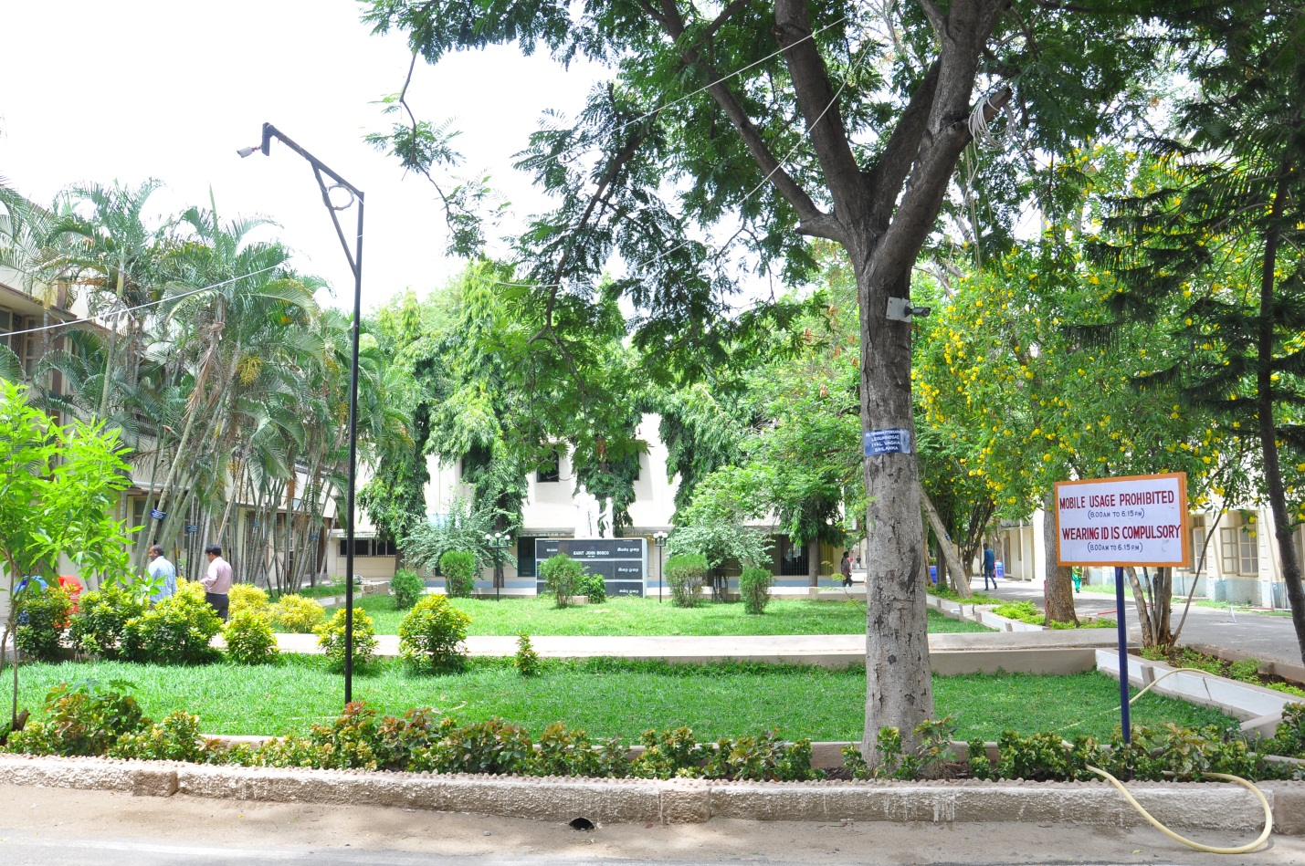

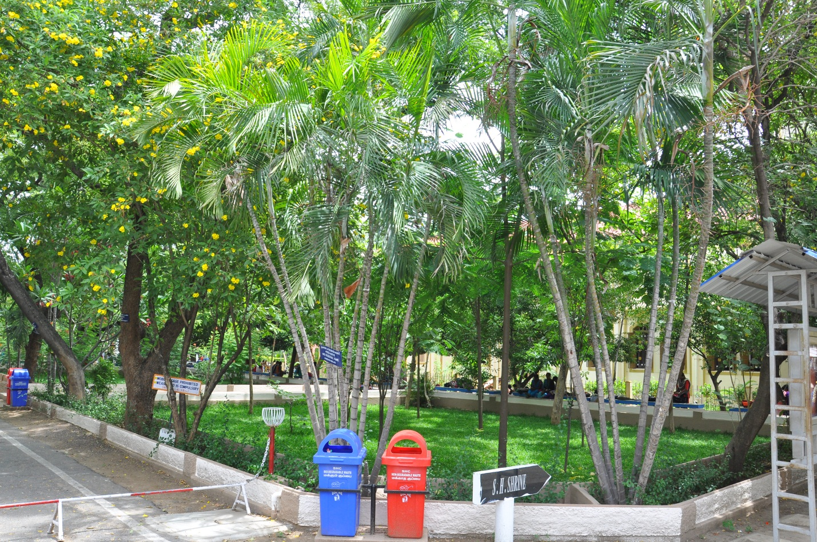
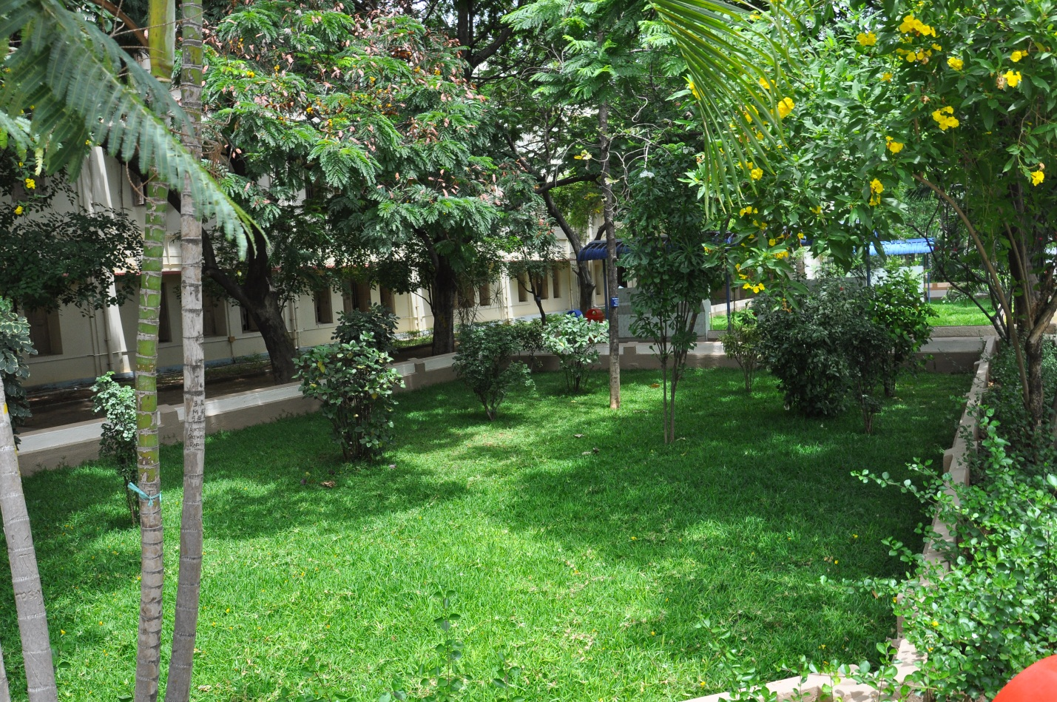

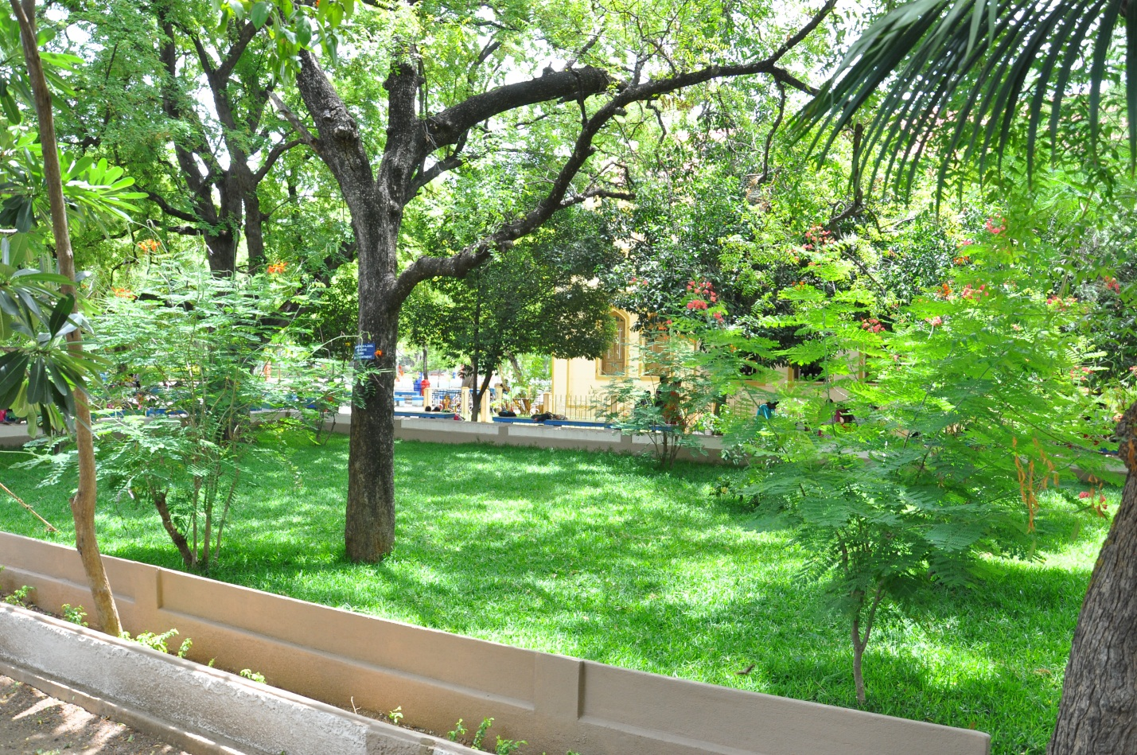
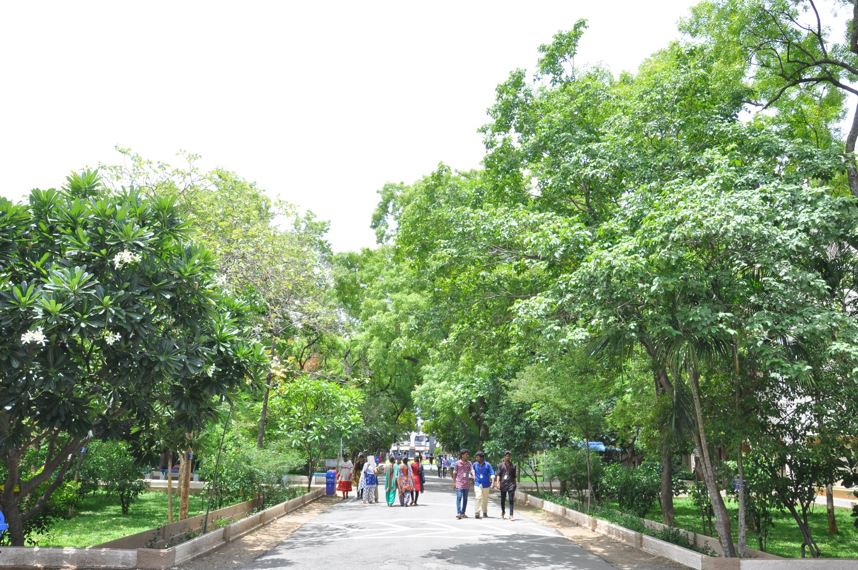
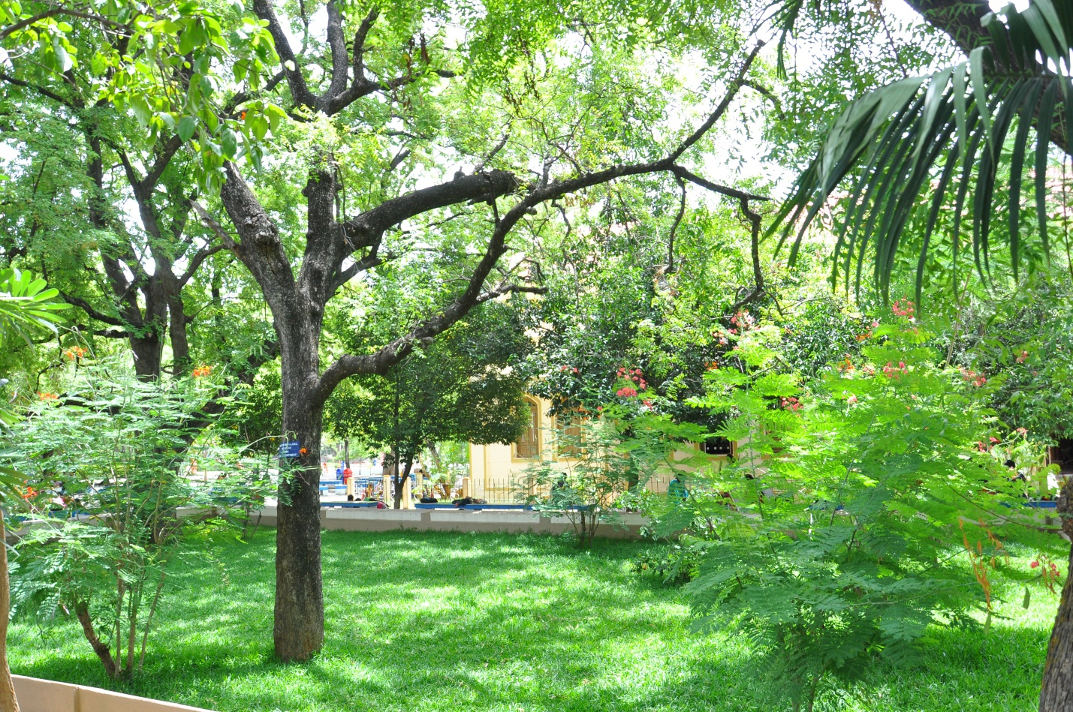
Green landscaping with trees and plants - (GREEN CAMPUS)

Sacred Heart College (Autonomous), Tirupattur – 635 601
Minutes of the HODs Meeting (Shift-I)
Date : 22:09:2017 Time : 11:45 a.m. Venue : Principal’s Office

The following members were present in the meeting.
Principal - Rev.Dr. D. Maria Antony Raj
Addl. Principal - Rev. Dr. Maria Arokiaraj
Vice Principal & COE - Rev. Dr. Praveen Peter
Vice Principal - Rev. Dr. G. TheophilAnand
Life Education - Rev. Dr. C. Antonyraj
Tamil - Dr. P. Selvakumar
English - Mr. N. Arul Doss
Economics - Mr. J. Missiadoss
History - Dr. D. Leslin
Commerce - Dr. K.A. Maria John Joseph
Mathematics - Dr. R. Murali
- Dr. A. George Maria Selvam
Physics - Dr. A. Albert Irudayraj
Chemistry - Dr.S.R. Xavier Rajarathinam
Computer Science - Dr. L. Ravi
BBA - Mr. R. Veerappan
Biochemistry& Microbiology - Mrs. R. Ananthalakshmi
MSW - Dr. S. Paul Raj
M.Sc. Comp. Science - Dr. S. Sagayaraj
M.Sc. Counselling Psychology - Rev. Sr. Anthoniammal
MCA - Mr. A. George Louis Raja
MBA - Dr. S. Sasikumar
Physical Education - Mr. A. Bento Devaraj
College Librarian - Mr. M. Selvam

Prayer and Welcoming
Rev.Dr.D.Maria Antony Raj, Principal initiated the meeting with a prayer. He prayed to the Spirit of the Lord to inspire the members to arrive at decisions towards the greater glory of the college.
Rev.Fr.Principal then welcomed the Heads of the Departments to the meeting and thanked them for their co-operation in organizing various programmes of the college including the Independence Day celebrations, Parents-Teachers Meeting, Women’s Day celebration, Feast of the Sacred Heart of Jesus, Governing Body Meeting and extended his words of appreciations to them.
Parents Meeting
Rev.Fr.Principal observed that the Parents waited for a long time during the Parents Meeting. Fr.Principal suggested that, the token system, which is adopted by some departments, can be extended to all the departments in the future.
Moodle
Rev.Fr.Principal mentioned that a Training Programme on the E-Learning Tool - MOODLE was conducted to facilitate the departments to deploy the E-Learning Pedagogy. He insisted the HoDs to plan along with the Moodle In-charges of the department to initiate and adapt to E-Learning framework. He also noted that the initiatives by NAAC and MHRD are directed towards digitalization of the Teaching and Learning Process, and steps like this would help the college to progress in the right direction. He mentioned that further proposals in this regard would be to implement the Google Scholar and Google Class Room applications.
Punctuality
Rev.Fr.Principal exhorted the Heads to focus on punctuality. He opined that coming to the classes on time is not the only dimension of punctuality. He felt that the Promptness should be practiced in all aspects including the submission of Question Papers, Preparation of official documents to the college and IQAC, Preparation of the time table etc.,.
Library Hour
Rev.Fr.Principal was glad to inform that most of the departments have started implementing the Library Hour and have included the library hour has a CA Component. He recommended that all the departments can consider the realization of Library Hour to induce the students to visit the library. He noted that the College Librarian has taken steps to arrange for a library tour to the first year Students and M.Phil., research scholars.
Staff and Department Profiles
Rev.Fr.Principal urged all the HoDs to insist their staff members to update their staff profile periodically and to fill up their personal annual plan. He mentioned that as per the directives of NAAC, the annual plan of the staff should be analyzed and included in the AQAR. He also reminded the Heads of the departments to keep their department profiles up-to-date, which will facilitated them to cull out any data instantly in a single click.
Saving Power
Fr.Principal initiated the discussion towards saving electricity in the campus. He put forth this agenda to the Heads and briefed them that some of the colleges have showcased this as their best practice. He looked forward for the consent of the HoDs, and after meticulous discussions, it was agreed to switch off the power between 8:45 a.m. – 9:30 a.m. on every Monday to save electricity and to help out the country in power conservation and to reduce global warming.
Pollution Control
Another discussion was triggered by Rev.Fr.Principal to consider the option of using the public transportation to reduce air pollution within the campus. After careful deliberations, it was decided to block out the private transport options and to use only the public transportation and Bi-Cycles on the first and third Mondays of every month.
Library Conference
The efforts of the Librarian Mr.M.Selvam, for organizing OARAC-2017, a national level conference on Open Access Resources for Academic Community on 21st and 22nd September were highly appreciated by Rev.Fr.Principal. He also acknowledged the Heads for allowing their research scholars to participate in the Conference.
ID Card
Rev.Fr.Principal noted that almost all the students are wearing the ID Cards during the working hours. He insisted that the HODs can remind their staff members to wear their Staff ID cards during the working hours.
E-Mail ID for the students
As per the directions of the NAAC, to facilitate their feedback mechanism, the college has been asked to persuade the students to create their own gmail id. Rev.Fr.Principal requested all the Heads to remind the students to create Gmail Id through the help of Dr.K.Arockiaraj, (Asst. Prof. Dept. Social Work), CQC Coordinator.
Scrutiny CA Question Papers and Preparation of Time Table
Rev.Fr.Principal reminded the HoDs to scrutinize the CA Question papers, and to draft the workload and Time table for the upcoming even semester.
Mid-Year Evaluation of the Departments
The mid year evaluation of the departments will be held during the CA Tests. In the mid year evaluation, only the HoDs will present their mid year evaluation report as per the prescribed template. However, the annual evaluation of the department at the end of this academic year will be conducted with the HoDs along with all the faculty of the department.
Annual Staff Retreat
Rev.Fr.Rector informed that the annual staff retreat will be held as scheduled in the college calendar on 27th and 28th of October. He mentioned that the retreat for Catholic, Non-catholic and Non Teaching Staff would be conducted simultaneously on the aforesaid dates.
Preparation of the AQAR
Dr.S.Sagayaraj, the IQAC coordinator, thanked all the Heads for their cooperation towards the preparation of AQAR. He briefed that the steering committee headed by Dr.L.Ravi along with criteria wise sub committees were constituted, and the chairman of the sub committees met on 30th August to initiate the preparations. Through the series of meetings on 19th and 20th of September, the sub committees have presented their suggestions to IQAC.
A tool has been materialized and a survey would be conducted among a selected population of 50% of students, to cull out their feedback on the Best practices of the college (i) Communicative English (ii) Student Counseling (iii) SHAPE. He requested the HoDs to submit the Department annual plan for 2017-18 at the earliest.
To facilitate the process of AQAR, it was decided to prepare a presentation and to circulate it through mail to all the heads of the departments.
Fr.Principal acknowledged the efforts of IQAC and Steering Committee towards the submission of AQAR, and cautiously reminded that the AQAR has to be uploaded by end of December, 2017.
Best Practices
After the suggestions of Dr.K.A. Maria John Joseph, Head,Department of Commerce, to consider the possibility of Projecting the Work Scholarship and Mid Day Meal Scheme to be the best practices of the college, the members went on for a thorough discussion.
Since, the Best practice projected by a institute, should have supporting evidence for a continuous period of 5 years, and because of the fact that communicative English and counseling schemes have grown from strength to strength after the previous NAAC Accreditation-2013. It was decided to project the Communicative English and Counseling Services as our best practices, and to consider the option of promoting Work Scholarship and Mid Day Meal schemes in the future.
Information
Rev.Fr.Principal informed that the Annual General Body meeting of the Higher Education Commission of the Chennai province is held in our premises on 23rd September in the DMT. He noted that Rev.Dr.Xavier Alphonse, S.J, an outstanding educationalist is delivering a talk at 9.30 a.m. on that day, and invited the Heads of the Departments to attend and benefit out of his session.
He also mentioned that the Meeting of the Salesian Brothers is scheduled on 23rd September in the John Med Block.
He reminded the HODs to work on and to establish MoUs and happy to note that Dr.I.Niyas Ahmed has signed up anMoU with Rev.Dr.InnasiMuthu.S.J.
Conclusion
The meeting came to an end with words of appreciation by Rev.Fr.Principal.

Minutes Prepared
Mr. A. George Louis Raja
Head, Dept. of MCA

